Topic: Predicting 30-Day Hospital Readmissions in Type 2 Diabetes Patients Using Machine Learning

Student Name:
Student ID:
Date of Submission:

Table of Contents
1 CHAPTER 1 INTRODUCTION 3
1.1 Background 3
1.2 Problem Statement 4
1.3 Research Aim 4
1.4 Research Objectives 4
1.5 Research Question 4
1.6 Significance & Motivation of the Study 5
1.7 Thesis Structure 5
2 CHAPTER 2 LITERATURE REVIEW 7
2.1 Chapter Overview 7
2.2 The Type 2 Diabetes Multifaceted Burden of Hospital Readmission 7
2.2.1 Clinical and Epidemiological Significance 7
2.2.2 Economic and Systemic Impact 8
2.3 Readmission Risk and the Limitations 10
2.4 Data and Methodological Revolution: new EHRs and machine learning 14
2.4.1 Appearing and Emerging of Electronic Health Records 14
2.4.2 Emergence of Machine Learning in Healthcare 15
2.5 Present State of Machine Learning in Hospital Readmission Prediction 16
2.5.1 ML to Predict Overall All-Cause Readmission 16
2.5.2 ML to Diabetes-Specific Prediction of Readmission 17
2.5.3 Acute Gaps in the Current Diabetes-centred ML Literature 17
2.6 Theoretical and Conceptual Framework 19
2.6.1 The Chronic Care Model (CCM) 19
2.7 Precision Medicine 21
2.8 Research Gap 22
2.9 Chapter Summary 23
3 CHAPTER 3: METHODOLOGY 24
3.1 Introduction 24
3.2 Research Design 24
3.3 Dataset Description 24
3.4 Data Preprocessing 25
3.4.1 Handling Missing Values 25
3.4.2 Target Variable Preparation 26
3.4.3 Encoding Categorical Variables 26
3.4.4 Handling Class Imbalance 26
3.4.5 Train-Test Split 27
3.5 Model Selection and Justification 27
3.5.1 Logistic Regression 27
3.5.2 Random Forest 28
3.5.3 XGBoost 28
3.6 Model Training 28
3.7 Model Evaluation Metrics 29
3.7.1 Accuracy 29
3.7.2 AUC-ROC Score 29
3.7.3 F1 Score 29
3.7.4 Decision Threshold Adjustment 30
3.8 SHAP Explainability 30
3.9 Ethical Considerations and Dataset Limitations 31
3.9.1 Missing Social Determinants 31
3.9.2 Data Age 32
3.9.3 Bias in Historical Data 32
3.9.4 Ethical Use 32
3.10 Tools and Technologies 32
3.11 Summary 33
4 References 34

CHAPTER 1 INTRODUCTION

Background
Diabetes can develop in both childhood and adulthood. In the Diabetes Atlas Number, 2021, it was found that 573 million people are diabetic, and this number is increasing year on year and is predicted to reach 777 million by 2040, as analysed in (Zheng et al, 2018). Connected diabetes care is replacing most of the expensive, less convenient face-to-face clinic visits. The revolution has guided the use of technology which is emerging as a valid alternative. The results were shown in COVID-19 epidemic which show the need for such models and the help they provide in healthcare Al-Badri and Hamdy (2021). In the 20th century, it was referred to as adult-onset diabetes (Mayo Clinic, 2025). Chandrasekaran and Weiskirchen (2024), have clarified that type 2 is more common than Type 1, accounting for 90-95% cases globally.
More than 80% of healthcare organisation leaders have an AI plan in place (Health IT Analytics, 2026). AI models are being integrated into models that will boost its effectiveness. Chronic Care Models was first adopted in January 1990 in which Clinical Information Systems (CIS), that are frequently integrated with or build upon Electronic Health Records (EHRs) and disease-specific register. Previously in Goh et al (2022) systematic reviews showed research gaps and mixed results when it came to evaluating CCM interventions in patients with type 2 diabetes. In CCM an important challenge arises is that there is a need for an evaluation of these models, so they can fit into different population and settings proving to be effective for them, as there is an unexplained heterogeneity for CCM intervention Timpel et al (2020). The CCM comprises of six components (1) community, (2) health system, (3) self-management support, (4) delivery system design, (5) decision support, and (6) clinical information systems.
A hospital readmission is when the patient is discharged from the facility, after a time, and is brought back to the hospital. The period varies in different sectors; the most common and widely used in standards is 30 days. The first stay in any hospital is called “index admission,” and the second stay is called “readmission.” An observational study of 1000 patients who were readmitted had a 27% chance of being prevented. The annual charge of readmission is $20 to 25 billion in the US alone. The risk of readmission is dependent on many factors. Diabetes is a chronic disease, and readmission is quite common in it. (Owusu et al., 2022). As explained by Daniel et al. (2023), the primary diagnosis of diabetes has a higher rate of readmission than those who have a secondary type of diabetes.

Problem Statement
Diabetes is one of the leading causes of hospitalisation in the world due to complications such as hyperglycaemia, cardiovascular issues, and infections. Hospitalisation is more common among type 2 diabetes patients, who are more likely to be readmitted each time after short-periods of time. These readmissions are unplanned and can often be avoided if the necessary measures are taken. In the fast-moving world of advanced computing, all the records of patients are saved digitally with security measures in place. To prevent readmission, an approach such as risk scores can be helpful in scoring and assessing the patient's health before discharge. Using traditional readmission risk scores does not often translate across a diverse patient population, because traditional readmission risk scores have a limited number of clinical features present. The introduction of electronic health records (EHR) systems has allowed for more distinct patient-specific prediction models. Machine learning can help create these specific models, which can have better patient-based outcomes. The use of machine learning in this domain holds the possibility to: (1) increase the identification of high-risk patients at an early stage, (2) helps in more targeted discharge plans to be made and suitable follow-up schedules to be followed up on, and (3) reduce preventable readmissions, thereby directly improving the efficiency of healthcare delivery and patient health concerns.

Research Aim
This research aims to assess models with machine learning-based prediction capabilities using electronic health record (EHR) data to accurately identify patients who have Type 2 diabetes who are at elevated risk of unplanned hospital readmission within 30 days of discharge.

Research Objectives
- To collect and clean Electronic Health Record (EHR) data for patients with Type 2 diabetes.
- To develop and train the machine learning models for predicting whether a patient is readmitted to the hospital within 30 days.
- To evaluate the models to figure out if they are working properly in predicting readmissions and comparing them with existing methods.

Research Question
- How can machine learning models be used to accurately predict 30-day hospital readmissions in patients with Type 2 diabetes using electronic health record data?

Significance & Motivation of the Study
The significance behind conducting this research lies in the necessity to reduce the high rates of unplanned 30-day readmission of patients diagnosed with Type 2 Diabetes Mellitus (T2DM) because this problem is a significant healthcare and clinical burden. The current clinical practice is mostly based on subjectivity or generic risk stratification instruments, like LACE and HOSPITAL. However, these instruments lack disease specificity, and normally they have low discriminative power. Moreover, they fail to account for the complexity and non-linearity of interactions between diabetes-specific variables, such as glycated haemoglobin (HbA1c) curves, indices of renal functions, and pharmacologic programs. In addition, the tools are static and do not take advantage of the longitudinal datasets that are now gathered in Electronic Health Records (EHRs). Therefore, this study aims to improve these gaps by applying machine learning (ML) techniques to the high-dimensional EHR data. ML models, especially ensemble methods, like Random Forest and Gradient Boosting, are sufficiently skilful operating with complex and heterogeneous data and can identify subtle risk patterns that the traditional techniques are unable to identify. Consequently, this study has enhanced the early detection of patients who are at elevated risk of readmission by creating a more accurate, data-driven, and risk assessment tool.
Unplanned hospital rehospitalisation within 30 days is one of the ongoing issues concerning chronic disease management, particularly with Type 2 diabetes patients. These admissions significantly add to the increasing healthcare costs, and they are linked to negative clinical outcomes and psychological stress. Although the clinicians might use standard criteria to determine people who are at elevated risk of rehospitalisation, they often tend to be subjective and have low predictive levels. Using machine learning on electronic health records (EHRs), it can be developed to create objective and more precise risk assessment tools that support clinical decisions. The motivation behind the study of the topic can be explained by the increasing convergence of health informatics and artificial intelligence, as well as the possibility of producing solutions that would increase real-world patient care with a minimum of technical complexity. Also, the desire to author a dissertation in the current semester makes this a topical and feasible subject, as there is accessible data and analysis tools.

Thesis Structure
This paper comprises five major chapters, which include an introduction, a literature review, a methodology, findings, and a conclusion. The background, problem statement, research objective, aim, question, and their significance have been outlined in the first chapter. Chapter 2 outlines the literature review, along with the views of different researchers on Type 2 diabetes patients and the prediction of 30-Day Hospital Readmissions. Chapter 3 highlights the research methodology that has been employed for the successful completion of this study, which includes philosophy, approach, and data collection methods. Chapter 4 interprets the findings and analysis that have been concluded employing the appropriate method. Lastly, chapter 5 gives the conclusion, presenting the summary of key findings, while also suggesting areas for future research. At the end of the thesis, a reference list has also been added, which was used to support the analysis and the research.

CHAPTER 2 LITERATURE REVIEW

Chapter Overview
Hospital readmission, particularly unexpected readmission within 30 days after discharge, is a key indicator of healthcare quality and a major economic issue for health systems worldwide. However, among patients with Type 2 Diabetes Mellitus (T2DM), as a complex and chronic illness requiring the intake of insulin and the development of pancreatic dysfunction of β-cells (Khin et al., 2023). The chances of readmission are significantly high, not only due to the acute complications of the condition but also due to the damage to the end-organs. Moreover, the readmission risk pattern in this population is not only a clinical issue but a complex interplay of biological, social, and system-level variables. Therefore, these readmission events have experienced a wonderful transformation through the academic avenue of accurately and promptly predicting their occurrence in three different periods which are reliance on clinician intuition and appraisal, offering of standardised risk scores when specific variables have undergone statistical modelling, and the present age of advanced machine learning algorithms in full Electronic Health Record (EHR) data, (Wang et al., 2021). Therefore, this development reflects more general trends within healthcare in the direction of data-constrained, personalised medicine and evidence-based practice.
Meanwhile, this literature review is systematic and finds five related thematic areas in whereby the existing research is synthesised. Although it first explores the clinical, epidemiological, and economic importance of diabetes-related readmissions, which sets the background and urgency of the issue. On the other hand, it critically examines the conventional predictive tools and their methodological and clinical weaknesses. However, third, it discusses the change in basic assumptions that happened following the digitalisation of healthcare data and the advent of machine learning as a methodological tool. Fourth, it offers a thorough analysis of the existing machine learning implementations in readmission prediction, especially focusing on diabetes-related research. At last, it lays down the theoretical and conceptual framework, which supports this research. Meanwhile, this review is conclusively balanced with a synthesis that shows the continuing gaps in the literature in nature with reference to the application of an individualised, interpretable, and clinically implementable machine learning model that is strictly suited to the heterogeneous T2DM patient population.

The Type 2 Diabetes Multifaceted Burden of Hospital Readmission

Clinical and Epidemiological Significance
Type 2 diabetes is a worldwide pandemic, and projection shows that the prevalence of the disease will be on the rise in both developed and developing countries (Abdul Basith Khan et al., 2020). However, being a systemic metabolic disease, its treatment is complicated by the emergence of both microvascular and macrovascular complications that often trigger hospital admissions (Zakir et al., 2023). Therefore, direct metabolic causes of admission include acute complications, like diabetic ketoacidosis (but it happens more often in Type 1, but appears in T2DM still during severe stress), hyperosmolar hyperglycaemic state, and severe hypoglycaemia (Gosmanov et al., 2021). Meanwhile, the usual reasons to be hospitalised are the conditions worsened by diabetes, which are cardiovascular events (myocardial infarction, stroke, heart failure), renal failure with the need to start dialysis, foot ulcers and infections with amputation, and other severe infections (Sharma et al., 2020). The literature has constantly shown that a diagnosis of T2DM raises the risk of readmission to the hospital significantly over all primary discharge diagnoses. The Conduct of seminal research in a diverse, large population of patients discovered that among many comorbidities and sociodemographic variables, diabetes remained one of the strongest independent predictors of 30-day readmission (Soh et al., 2020).
Compared the strength of this correlation and found that Medicare beneficiaries with diabetes were about 1.4 times more likely to be admitted again than non-diabetic people, and that the risk was especially high in the case of first hospitalisation associated with either circulatory or respiratory diseases (Mohebbi, 2020). Therefore, even the readmission phenomenon is more of a sentinel event rather than a single instance in the health course of a patient (Hemmingsen et al., 2025). However, it can represent a critical failure in one or more areas of the care continuum, which includes inefficient care transfer between hospital and community care, inefficient medication handover to cause errors or non-adherence, insufficient patient education about self-management in the vulnerable post-discharge phase, or the failure to compensate for uncontrolled comorbid conditions. As a result, the readmission rates have turned into the central quality indicator of hospitals and health systems, taking the place in the value-based payment models as the measure of care coordination and effectiveness of disease management over the long term.

Economic and Systemic Impact
Preventable readmissions form a major point of attack in cost-containment efforts in ever-straining healthcare systems, in terms of health economics and policy. However, the Hospital Readmissions Reduction Program (HRRP), a program instituted by the Affordable Care Act in the United States to penalise hospitals with higher-than-predicted readmission rates of specific diseases, which provides financial penalties against specific hospitals with particularly high prevalence rates and worse outcomes in the diabetic population, which have traditionally included heart failure, acute myocardial infarction, and pneumonia, (Qiu et al., 2022). On the prohibitive cost of penalties, which may be in the millions of dollars of decreased Medicare funds to changed institutions, therefore generating an effective institutional incentive to develop effective prediction and prevention plans (Blick et al., 2023). Moreover, direct healthcare expenditures related to a readmission are high, and they include frequent diagnostic testing, escalating pharmacological and targeted nursing and specialist care, and procedures (Kum Ghabowen et al., 2024). Nonetheless, the economic cost does not just amount to direct medical expenditure (Jha et al., 2023).
In addition, the indirect costs are the lost productivity of patients and caregivers, the cost of transportation, and the economic cost in the long term of accelerated disability. Although the cumulative cost is enormous to patients with T2DM who tend to incur many readmissions throughout the years, the health systems have a twin mandate, which has an ethical responsibility to enhance patient outcomes, and a functional responsibility to ensure resource efficiency (Regassa et al., 2021). Therefore, predictive models that are effective in detecting high-risk patients are an avenue through which both imperatives may be met, providing the means to focus effective interventions, which would be cost-effective, to avoid expensive readmission events.

Dimension | Specific Factors | Impact & Consequences
Clinical Drivers | Acute metabolic complications (HHS, severe hypoglycaemia); Cardiovascular events; Renal failure; Severe infections (e.g., osteomyelitis). | Increased morbidity and mortality; Accelerated disease progression; Reduced functional status.
System & Process Drivers | Poor care transitions; Medication errors at discharge; Lack of prompt follow-up; Inadequate patient education. | Breakdown in care continuity; Patient and caregiver frustration; Erosion of trust in the health system.
Patient-Level Drivers | Low health literacy; Socioeconomic barriers (transportation, cost); Complex self-care regimens; Comorbid depression/anxiety. | Non-adherence to treatment plans, delayed help-seeking, and Higher all-cause mortality.
Economic Impact | Direct medical costs of readmission; HRRP financial penalties; Indirect costs (productivity loss). | Strain on hospital budgets; Redirected resources from other services; Increased insurance premiums.
Quality Metric Impact | 30-day readmission rate; Patient satisfaction scores (HCAHPS); Mortality measures. | Public reporting and reputation; Value-based payment adjustments; Regulatory scrutiny.
Table 1: Specific Factors and their impact

Readmission Risk and the Limitations
The search to find the patients at the greatest risk of readmission is not new to the digital age, and the first attempts to do so were based on clinician experience and judgement. Although valuable, as a method, this intuitive approach is inherently subjective, and it is not consistent between providers, nor is it easy to scale. To this challenge, a body of standardised risk prediction instruments made up of score-based methods was created and confirmed in the late 20th and early 21st centuries, aimed at introducing objectivity and repeatability into risk assessment. One of the most proliferated generic instruments is the LACE index, which uses four factors which including Length of stay (L), Acuity of the admission (A), Comorbidity (C) based on the Charlson Comorbidity Index, and Emergency department use (E) within the six months preceding (Ben-Assuli et al., 2020). On the same note, the HOSPITAL score uses the following parameters, which are Haemoglobin level at discharge, discharge dis Oncology service, Sodium level, Procedure during admission, Index admission Type, number of Admissions last year, and Length of stay. Meanwhile, their popularity is enhanced by the fact that they are parsimonious and may be computed either at the bedside or based on administrative information.
Although a generic instrument, like LACE and HOSPITAL can be used to provide a consistent baseline for risk assessment, it significantly suffers because it uses a “one-fit-all-purpose methodology that does not acknowledge the accurate pathophysiology of Type 2 Diabetes Mellitus (T2DM). According to Rajaguru et al. (2022), LACE is beneficial in being assessable to identify patients who are at elevated risk of readmission to get interventions and potentially avoidable readmission. However, general scores are based on administrative measurements like length of stay and use of emergency department in the past. Conversely, the indications of diabetes (e.g., the glycaemic variability, the albuminuria, special drug use) provide high face validity and clinical significance for this population. Therefore, the proposed study emphasizes the need to transform the focus from the less specific, i.e., generic, variables of LACE into the diabetes specific clinical drivers, which is necessary to break the current predictive level in the readmission models.
Efforts to identify patients at highest risk of readmission predate the era of digital healthcare. Historically, clinicians relied on professional judgement, pattern recognition, and experiential knowledge when assessing discharge risk. While clinically valuable, this approach is inherently subjective, difficult to standardise, and vulnerable to inter-observer variability. To improve consistency, several structured risk prediction tools were developed during the late twentieth and early twenty-first centuries. Among the most widely used is the LACE Index, which incorporates Length of stay, Acuity of admission, Charlson Comorbidity Index, and recent Emergency department use (Ben-Assuli et al., 2020). Another commonly used instrument is the HOSPITAL score, based on haemoglobin level, discharge from oncology service, sodium level, procedure during admission, index admission type, prior admissions, and length of stay. These tools gained popularity because they are parsimonious, low-cost, and feasible to implement using routine administrative data.
Despite their operational simplicity, generic tools such as LACE and HOSPITAL possess substantial limitations when applied to patients with T2DM. Their construction is population-general rather than disease-specific, meaning they do not capture key diabetes-related predictors such as glycaemic variability, HbA1c trajectory, insulin dependence, albuminuria, renal decline, medication complexity, or history of severe hypoglycaemia (Rajaguru et al., 2022). As a result, their clinical face validity within diabetes cohorts is restricted. Validation studies indicate that while such tools perform better than chance, their discrimination is modest, with Area Under the Receiver Operating Characteristic Curve (AUC-ROC) values commonly ranging between 0.60 and 0.70 (Cilloniz et al., 2023). In practical terms, this level of accuracy is often insufficient to justify costly targeted interventions or reliable discharge triage decisions. To address these shortcomings, disease-specific models for diabetic populations have been proposed. These models typically employ logistic regression using selected diabetes-related variables such as comorbid burden, medication type, and laboratory indicators. Although they improve contextual relevance, they often remain constrained by traditional statistical assumptions (Jiang, 2020). Most rely on linear relationships, limited variable sets, and manually selected predictors, reducing their capacity to model complex interactions present in chronic disease populations.
For example, the relationship between renal impairment, glycaemic instability, and treatment modality may be highly non-linear and dynamic. A patient receiving insulin with worsening kidney function may face substantially different readmission risk than a patient with similar HbA1c controlled on oral therapy alone. Conventional regression methods frequently struggle to capture these layered interactions. Another critical limitation is their static design. Many traditional models utilise cross-sectional information captured only at discharge, thereby ignoring valuable longitudinal data such as trends in laboratory values, repeated utilisation history, medication adherence patterns, and missed outpatient appointments. In addition, they rarely incorporate social determinants of health such as transport barriers, housing instability, low health literacy, food insecurity, or caregiver support, despite strong evidence linking these variables to readmission outcomes.
These weaknesses can be summarised in four areas. First, predictive performance remains moderate, limiting operational usefulness. Second, models are insufficiently personalised and fail to account for heterogeneity within T2DM populations. Third, they are temporally static and unable to exploit longitudinal patient trajectories. Fourth, they underrepresent non-clinical determinants increasingly recognised as fundamental drivers of healthcare utilisation. Consequently, there is a clear methodological rationale for more advanced predictive approaches capable of integrating large-scale EHR data, modelling non-linear relationships, learning temporal patterns, and generating patient-specific risk estimates. This need has directly contributed to growing interest in machine learning approaches for hospital readmission prediction.
However, as pointed out in a substantial systematic review of readmission risk prediction models conducted by Jiang (2020), even disease-specific models are plagued by serious limitations. Nevertheless, they rely mostly on the traditional approaches to statistics, such as logistic regression, which is inconsistent with high-dimensional data and the more complex and non-linear nature of complex interactions among variables. Usually, they use a pre-defined, narrow set of variables (usually less than 20), selected a priori, either by researcher judgment or on a univariate basis. This step stands to lose potentially valuable, albeit less significant, predictors, as well as does not account for the complex interdependencies present in such a complex chronic disease as T2DM. As an illustration, the relationship between glycaemic variability and renal functioning and a medication (e.g., SGLT2 inhibitors) might have a non-linear correlation with readmission risk, which cannot be accurately represented with the help of linear models.
Moreover, conventional models are mostly stagnant and cross-sectional. In many cases, build on data at one point in time (usually at discharge) and do not take advantage of the valuable longitudinal information available in current EHRs, including lab value trends, time-to-time medication adherence, or outpatient contact. Most significantly, they often do not include powerful non-clinical determinants of health. Health literacy, social support network, access to transportation, housing stability and access to financial resources to purchase medications are some of these factors which are known to be hard to record in structured data fields yet they are always cited in qualitative research and in the research dealing with health services as insignificant to influence the result of patients with non-communicable diseases similar to diabetes.
The weaknesses of the conventional strategies can be systematised into the following. They are predictively low and moderate, with AUCs seldom reaching the 0.75 mark, radically reducing their clinical usefulness and cost-effectiveness in their role as intervention guides. They are not personalised, their method is one-size-fits-all and does not accommodate such heterogeneity in the T2DM population that is characterised by differences in age of onset, prevalence of disease, comorbidities, and interventions. However, they are designed to be static and retrospective, and use information at one time point, and are not dynamic to incorporate longitudinal patient trajectories, which would provide a more refined risk assessment. Lastly, they disregard important non-clinical determinants, neglecting socioeconomic determinants, behavioural patterns, and healthcare access determinants, which are increasingly being taken as a primary cause of health outcomes and use.
According to the Pathophysiological and Pharmacological Drivers in T2DM Hospital Readmission, the derived predictive categories for T2DM readmission can be divided into three clinical domains, among which the first one is longitudinal glycaemic trends. In addition to a single HbA1c at discharge, the shape of HbA1c curves over one year gives a peek preview into long-term disease stability or its worsening. The second is the renal and end organ indices, in which factors like serum creatinine levels and the existence of nephropathy or retinopathy are all good predictors because renal failure makes recovery at the end of discharge exceedingly difficult. The third is the complexity in pharmacology, however, there is a significant variation in the risk profile according to the modality of treatment. Patients on multifaceted insulin-dependent medications are more exposed to acute metabolic issues, like hypoglycaemia compared to the patients who are on newer and cardio-protective pharmacologic programs, like SGLT2 inhibitors or GLP-1 RA therapies. Even though they both are having a comparable effect on composite cardiovascular endpoints, a significant reduction in death risks or heart failure in hospitals have been shown by SGLT2 inhibitors (Rolek et al., 2023).
Characteristic | Clinician Intuition | Generic Risk Scores (e.g., LACE, HOSPITAL) | Disease-Specific Statistical Models (e.g., for Diabetes)
Basis of Prediction | Experience, pattern recognition, Gestalt. | Multivariable regression on selected factors from general populations. | Multivariable regression on selected clinical factors from diabetic cohorts.
Key Advantages | Can incorporate subtle, non-codified patient factors; Flexible. | Objective, reproducible, easy to calculate; Eases standardisation. | More clinically relevant variables for the target population; Better face validity.
Key Limitations | Subjective, variable, non-scalable, prone to bias. | Low disease specificity; Modest discrimination (AUC ~0.65-0.70); Omits key disease factors. | Limited to pre-selected variables; Cannot model complex interactions; Often ignores social determinants.
Data Utilisation | Unstructured clinical narrative. | Few structured variables (4-8). | Moderate number of structured clinical variables (10-25).
Handling of Complexity | High but inconsistent. | Very Low. | Low to Moderate.
Primary Use Case | Individual patient assessment at the bedside. | Population-level screening and risk stratification. | Disease-program management and quality improvement.

Table 2: Readmission Risk and the Limitations

Data and Methodological Revolution: new EHRs and machine learning

Appearing and Emerging of Electronic Health Records
The move toward the use of paper-based charts to full Electronic Health Records in the last 20 years has resulted in the development of repositories of patient data never seen before. However, the modern EHRs fuse together coded data (diagnoses, medications, laboratory findings, vital signs), semi-structured data (clinical notes, discharge summaries), and unstructured data (imaging reports, physician free-text narratives) to a greater degree. Meanwhile, this digitisation results in the longitudinal, multidimensional digital phenotype of every patient, which records their health experience in terms of encounters, settings, and time. Whereas this real-world data is indispensable about research and prediction.
According to the systematic search of the EHRs, which was developed by Santos (2021) by applying machine learning to electronic health records: a study on two adverse events, it becomes possible to uncover some before unknown patterns, risk correlations, and course of diseases that cannot be noticed through smaller, customised research samples or a dataset of administrative claims. The amount of EHR data expressed as granules, e.g., a trend of serum creatinine in a patient over half a year, or the list of medications prescribed and cleared, serves as a fertile food material to construct more dynamic, refined, and individual predictive models. The difficulty and the challenge are how to devise techniques to glean valuable insights out of this high-dimensional, noisy, and even incomplete source of data.

Emergence of Machine Learning in Healthcare

2.4.2 Emergence of Machine Learning in Healthcare
The rapid expansion of digitised healthcare data has created an environment in which conventional statistical techniques are often insufficient to derive accurate and scalable predictive insights from large, heterogeneous, and high-dimensional datasets. In response, machine learning (ML), a specialised branch of artificial intelligence, has emerged as a transformative analytical approach within healthcare systems. Machine learning refers to computational methods that learn patterns from historical data and iteratively improve predictive performance without requiring explicitly programmed rules for every scenario (Helm et al., 2020; Martínez-García et al., 2022).
Unlike traditional regression-based techniques, where the functional relationship between predictors and outcomes is commonly specified in advance by the researcher, ML algorithms can automatically identify latent associations, hidden structures, and non-linear dependencies directly from the data. This capability is highly valuable in healthcare, where patient outcomes are rarely driven by a single factor and are more often shaped by interacting clinical, behavioural, environmental, and organisational variables (Helm et al., 2020; Wang et al., 2021).
One of the most significant advantages of machine learning is its ability to process high-dimensional datasets. Contemporary Electronic Health Records (EHRs) may include hundreds of variables such as diagnostic histories, medication exposure, laboratory trends, physiological observations, service utilisation metrics, and demographic indicators. Conventional models frequently experience instability or reduced performance when exposed to such complexity. In contrast, ML algorithms can employ feature selection, regularisation, and dimensionality reduction strategies to identify the most predictive inputs while limiting overfitting (Martínez-García et al., 2022; Santos, 2021).
A further strength of machine learning lies in its ability to model non-linear relationships and variable interactions. In healthcare settings, risk rarely changes in a purely linear manner. For example, the effect of age on readmission may vary depending on renal impairment, medication burden, or previous utilisation history. Similarly, glycaemic instability may have different implications across patient subgroups. Algorithms such as Random Forest, Gradient Boosting Machines, and XGBoost are particularly effective in learning such complex relationships without requiring manual specification by the analyst (Helm et al., 2020; Sahin, 2020).
Machine learning is also highly suited to temporal and sequential patient data. Health status evolves continuously over time rather than existing as a static condition at discharge. Advanced architectures such as Recurrent Neural Networks (RNNs), Long Short-Term Memory (LSTM) networks, and transformer-based models can analyse sequential patterns including repeated glucose measures, changing renal function, medication adherence trajectories, or recurrent admissions. This enables predictive modelling to move from static classification toward dynamic risk forecasting (Wang et al., 2021; Sivarajkumar, 2025).
The practical application of ML in healthcare has already demonstrated substantial promise across multiple domains. These include diabetic retinopathy detection, radiological image interpretation, tumour classification, natural language processing of clinical notes, mortality prediction, sepsis alerts, and hospital operations management. Such successes have increased confidence in the suitability of machine learning for prognostic tasks such as hospital readmission prediction (Martínez-García et al., 2022; Olalekan Kehinde, 2025).
Despite these strengths, implementation barriers remain significant. Many high-performing models are criticised for limited interpretability, particularly deep learning systems that operate as “black boxes.” Clinicians often require transparent reasoning before relying on algorithmic outputs in practice. Additional concerns include data quality issues, missing values, algorithmic bias, fairness across demographic groups, model drift over time, and integration into clinical workflows (Rane et al., 2024; Wakim et al., 2020).
Nevertheless, the analytical strengths of machine learning—including scalability, adaptive learning, pattern recognition, and predictive precision—make it particularly relevant to chronic and multifactorial diseases such as Type 2 Diabetes Mellitus. Since readmission risk in diabetic populations is influenced by numerous interacting variables across time, ML provides a robust methodological foundation for next-generation predictive modelling. Consequently, its use in diabetes-related readmission forecasting has become an increasingly important field of contemporary research (Wang et al., 2021; De Graaf et al., 2023).

Present State of Machine Learning in Hospital Readmission Prediction
The use of ML with readmission prediction has given rise to a mass of literature, which can be analysed in two directions which including studies of all-cause readmission prediction in the general population of patients, and more narrow research of the diabetes-specific cohort.

ML to Predict Overall All-Cause Readmission
Premature comparative research tried to set up whether ML algorithms can be superior to standard logistic regression to predict overall 30-day readmissions. Dar studied this et al. (2021), who decided that although some of the ML models, like Random Forests and Support Vector Machines, proved an increase, they decreased by a smallish margin compared to their well-specified logistic regression when trained with similar features. However, this observation underscored that using overly sophisticated algorithms without colourful information does not hint at much effectiveness. The change in basic assumptions came with investigations that capitalised on the quantity and the richness of the EHR information. Further research by Regan (2022) is a sign of the strength of scale and data heterogeneity. Meanwhile, they applied deep learning models on an exceptionally large dataset of EHR, including both structured data and clinical note information among different hospitals, reaching AUCs over 0.80 in predicting several inpatient outcomes, such as readmission. However, this article highlighted the possibility of predictive performance to climb beyond the point of feeling with such a huge amount of data and a powerful algorithmic system.
This body of work on general readmissions has presented several important themes and insights. To begin with, ensemble classification, specifically tree models such as Random Forest and Gradient Boosting Machines (such as XGBoost), has always outperformed individual models, such as logistic regression or decision trees (Sahin, 2020). Their instruments are powerful and dependable since they can bring together many poor learners and model complex patterns. Second, the results of feature importance assessments with these models show that non-clinical and healthcare use variables are most predictive. However, the number of earlier admissions, the number of medications (a proxy of complexity), and indicators of socioeconomic difficulties are among the first variables that should be considered, rather than direct laboratory results or diagnoses. Third, there is a large body of models with an AUC of 0.75-0.85 that some researchers hypothesise is an AUC Plateau predicting readmissions with existing sources of EHR data (Sivarajkumar, 2025). Moreover, to break this plateau, it may be necessary to add new data streams, like wearable-generated patient health data or communal community database social determinants of health, or even more advanced processing of clinical notes. Lastly, clinical implementation is another significant theme that is critical and persistent. Although excellent discriminative performance is and has been reported in many papers based on retrospective studies, very few ML-based readmission prediction models have been effectively deployed into live clinical workflows (Olalekan Kehinde, 2025). Furthermore, the challenges consist of the fact that many algorithms that achieve high results are black box in nature, leading to a decrease in clinician trust, technical obstacles to implementing models to act in real-time to make inferences at the point of care; and the existence of insufficient evidence on how to effectively convert a risk score into an actionable, cost-effective intervention to improve outcomes.

ML to Diabetes-Specific Prediction of Readmission
Numerous studies have concentrated on predicting readmissions in patients with T2DM are less in number but represent an important and expanding niche. Such studies tend to take either one of two methods. The first method is to forecast all-cause readmission in a patient population that is selected based on the presence of T2DM. However, this is important to realise that a patient with diabetes can be re-hospitalised due to any cause and not necessarily due to diabetes related complications. Recently, De Graaf et al. (2023) employed a large, multi-centre EHR database to achieve this objective by training a gradient boosting model, and they got an AUC of 0.78 by including a wide range of functions (retinopathy, nephropathy, neuropathy, etc), and longitudinal lab trends are also included. However, examination of the significance of features confirmed the predictive quality of end-organ harm attributable to diabetes and the frequency of prior hospitalisation, as well as indicators of renal function.
The second strategy is devoted to predicting readmission among, diabetes-related acute diseases, including diabetic ketoacidosis (DKA) or extreme hypoglycaemia. It is a more specific forecasting exercise. As an example, Johnson (2025) created a model to expect 30-day DKA readmission. Their model emphasised the dynamic and longitudinal variables, including the trend of HbA1c before the index admission period and a history of past DKA episodes, and discharge preparedness variables such as the timing of follow-up appointment schedules.

Acute Gaps in the Current Diabetes-centred ML Literature
The systematic review of the existing studies, although this research approach undoubtedly has a prospect of success, presents many important and interconnected gaps that the thesis proposed is supposed to fill. The first one is to consider the excessive heterogeneity of the T2DM population (Redondo et al., 2020). Most available models consider diabetes as a dichotomous, mono-comorbidity checkbox. However, the clinical reality of T2DM is a continuum between diet-controlled disease in a young adult, where the insulin levels are normal, and insulin-dependent disease with a variety of complications in an elderly patient. Very high prediction accuracy needs models that are trained and capable of adjusting to this inner heterogeneity, and in such a way that gives readmission prospects differentially depending on risk factors such as age of onset, duration, presence of certain complications (e.g., heart failure vs. chronic kidney disease), and the modality of treatment (e.g., insulin use, GLP-1 RA treatment).
Second, the issue of the trade-off between the interpretability and performance of the model is urgent. Deep neural networks or sophisticated ensembles are the most potent ML models, and tend to have the highest AUCs, which are characterised as black boxes, which cannot give much information on why a specific prediction was made (Rane et al., 2024). Clinicians need cognitive interpretability to trust, accept, and act on a model. However, they must know what the major risk factors are of the individual patient-is it more about renal functionality, or is it some social reason, or more about the complexity of the medication? Explainable model methods, like SHAP (Shapley Additive explanations) and LIME (Local Interpretable Model-agnostic Explanations), have become popular in the wider ML literature but have not been applied as systematically and rigorously to the diabetes readmission model. The abundance of correct and interpretable models would be a significant breakthrough in the form of a model.
Third, most existing models do not provide enough temporal granularity and longitudinal analysis (Wakim et al., 2020). They are mostly based on a one-point time (at the time of discharge), a cross-sectional view of patient status. However, this ignores the significant predictive data during the health status of a patient. A history of HbA1C levels in the last year (increasing, not changing, treating) in the case of a diabetic patient, the shape of change in the weight or the rate of earlier outpatient appointments can be more instructive compared to a single admission. These longitudinal beginnings must be used in risk assessment by incorporating these longitudinal beginnings with proper feature engineering methods or sequence-modelling (such as mining of sliding windows statistics or RNNs).
At last, there is a gap in the literature about the clinical actionability of predictions. Meanwhile, a list of key features and a report of discrimination measurements (AUC, precision, recall) are often the results of many studies (Mahmoudi et al., 2020). A less explored aspect is the essential step to be taken next, namely, how this model output needs to be implemented into a clinical workflow to become effective in preventing readmission in real life. In addition, the methods of transforming a risk score and the factors that explain it into a particular and prioritised intervention plan must be researched. Does the high-risk score cause a pharmacist-led medication review, a social work consult, a 48-hour post-discharge scheduled telehealth check-in, or all three? Sealing the gap between the possibility of prediction versus intervention is crucial to achieving the full potential of the ML models in practice care.

Theoretical and Conceptual Framework

The Chronic Care Model (CCM)
The Chronic Care Model is an evidence-based, organisational approach created by Wagner and others during the 1990s that aimed at changing the care received by patients with chronic illnesses to a planned, rather than reactive, and episodic approach to care (Fortin et al., 2021). Moreover, the general argument of the CCM is that the interaction of an activated and informed patient with a ready and initiative-taking practice team is how positive health outcomes are obtained. A healthcare system based on six elements that interact with each other promotes this productive interaction (Renzulli, 2021). The first one is the Leadership's dedication to quality growth, investment towards chronic care, and rewards corresponding with satisfactory results. Secondly, an intervention using registries (CIS) that share data systems and decision support, which are used to structure patient and population data to be proactively used. The third one is organising a redesign of clinical workflow, effective team care, scheduled visits, and follow-up. The fourth one is implementing an evidence-based method in day-to-day practice by education, reminders, and specialist aid. The fifth one is self-management support, which means that patients should be empowered, encompassing jointly set goals, support to solve problems, and/or with the help of readily available resources. And the last one is moving the outside resources to aid patients beyond clinical environments.
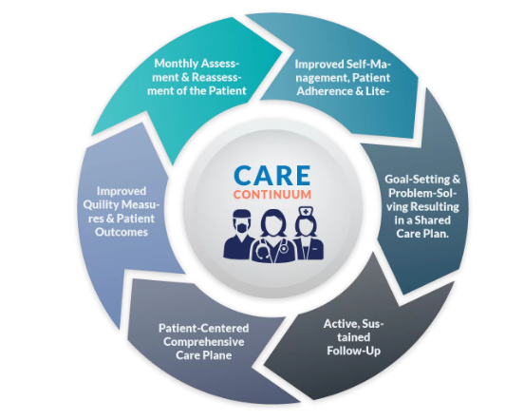
Figure 1: Chronic Care Model
Source: CareVitality (2020)

To move beyond a theoretical model, the proposed machine learning algorithm is clearly distinguished by the key components of the CCM to guarantee a clinical relevance and actionability. However, the following mapping determines the alignment between certain model features and goals with the six components of the CCM. Firstly, the Clinical Information Systems (CIS), with Electronic Health Records (EHR) longitudinal depth as its input, the ML algorithm use this as the input. Moreover, through CIS physicians can analyse the condition of their patients, choose suitable treatment options, and can monitor wellness activities (Tun et al., 2023). The model achieves the objective of the CCM to proactively manage patients’ populations using shared data systems by converting raw registries to a structured digital phenotype, such as Marty-1 HbA1c patterns and serum creatinine changes. Secondly, decision support in which the algorithm is not serving as a passive score; but it is intended to be an evidence-based decision supporting tool. It gives clinicians a reminder and specialist assistance (at the point of discharge) by placing emphasis on high-risk factors (i.e., the glycaemic fluctuations or the complexity of medications) demanding urgent action, helps in resource allocation, and in public health policy making (Jayatilake et al., 2021). Moreover, in the self-management support, the model determines the non-clinical predictors of readmission, which include low health literacy and complicated self-care practices. The algorithm alerts patients at risk of these complications, while initiating specific education and goal-setting interventions to enable them to manage their condition more effectively after discharge. For the delivery system design, the output of the algorithm is used to redesign clinical processes and include high-risk patients in planned follow-ups and multidisciplinary team care to guarantee that the limited hospital facilities are allocated to the area of greatest need. Lastly, in terms of health system organization and community resources, the model assists the leadership in prioritizing the distribution of community-based resources to patients because the readmission risk of non-clinical factors within the community is quantified by the tool.

Precision Medicine
Precision Medicine is a current medical trend that aims to personalise the prevention, diagnosis, and treatment of different patients. It goes beyond the traditional one-size-fits-all method, which is founded on average responses among wide populations (Sbitan et al., 2025). Moreover, its main pillars include deep phenotyping, which is done by gaining high-resolution clinical, molecular, environmental, and behavioural profiles, advanced analytics by finding patterns in complex data with the help of computational tools, and actionable stratification by categorising patients into subgroups to make specific interventions.

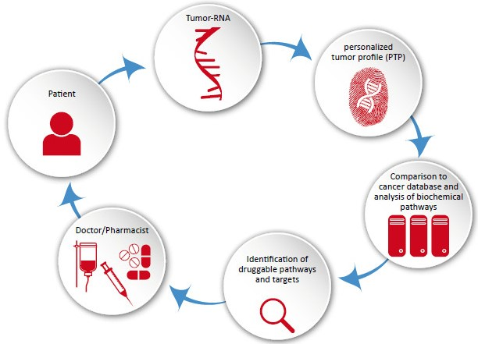
Figure 2: Precision Medicine
Source: GenxPro (2015)
This thesis can be applied to the issue of readmissions using precision medicine. First, it shifts away from the generic prediction to the customised prediction of the T2DM population kind with disease-specific accuracy (Wang, 2023). In addition to this, it involves the use of deep clinical phenotyping with the use of EHRs, which combines various data points into individual profiles. At last, a high-risk patient with renal dysfunction and non-adherence to medication would have a different intervention package than a patient with uncontrolled hyperglycaemia and the absence of social support.

Research Gap
The issue of hospital readmission of Type 2 Diabetes patients is a clinically crucial, economically debilitating, and to a significant degree, potentially avoidable issue. The classic prediction instruments of this risk, as traditional as they are, are limited by methodological inaccuracy, which restrains their accuracy and their clinical applicability. However, the simultaneous advancement of cohesive Electronic Health Records and progressive machine learning software is a revolutionary chance to cut these shortcomings. Therefore, to implement ML in readmission prediction, both generally and in diabetes populations, promising improvements in predictive capability are achieved. Nevertheless, this emerging literature has some serious gaps. Most of the models are either too generic and lack the focus on the specific heterogeneity of T2DM, or are complex black boxes, not allowing them to be trusted and adopted in clinical practice.
High discrimination metrics in reflective research are prioritised, and there is a lack of focus on the interpretability of model outputs, making use of longitudinal data signatures, and, moreover, translating predictions into evidence-based clinical pathways. Therefore, the selection of the core research gap is the necessity to create and thoroughly evaluate a machine learning model specifically designed to predict 30-day readmissions in patients with Type 2 diabetes who consciously choose its priority and aim to improve its predictive accuracy, clinical interpretability, and actionability. In addition to this, the model should be crafted to understand the internal heterogeneity of the disease and be able to sufficiently harness extensive longitudinal EHR practice beyond cross-sectional snapshots and give the reasoning support to its predictions in a transparent and clinically meaningful manner, to enable credibility and direct specific interventions. However, this thesis aims to fill this specific gap by adding a step towards a smarter, explainable, and more practical tool in the decision support used by the management of a chronic disease on a major scale.

Chapter Summary
In the end, it is concluded that this review has explored the historical and conceptual framework of readmission risk prediction of Type 2 diabetes, opposing the transition of a subjective assessment to algorithmic forecasting using data. However, it has been defined that the significant weight of the issue criticises the constraints of the current procedure and discusses the transformative prospects of machine learning to rich EHR information. Therefore, the evaluation in the existing ML applications suggests that it is a field that continues to evolve, showing effectiveness in technology, but also showing prospects of issues that still are unsolved in the areas of disease-specificity, model transparency, and its usage in clinical practices.
In addition to this, the combination of the Chronic Care Model and Precision Medicine theoretically gives the current study a good theoretical framework. Instead of viewing the proposed ML model as a one-dimensional technological item, the proposed ML model is meant to support by adding another layer to the chronic disease care system, making it more precise, more initiative-taking, and patient centred. Although machine learning has the potential to be an effective innovative approach, therefore, the next stage is to transfer it to clinical practice aimed at improving the outcomes of T2DM, which requires transitioning away from a close focus on algorithmic performance metrics. The literature that is currently needed is the development of models that are not only accurate but must also be interpretable, context-aware in the context of both the disease itself and the own care system, and their development has to be focused on clinical workflow integration and actionability as an intended outcome. At last, this thesis acts like a direct contributor to the second step, which is creating and assessing the model that fills the determined gaps between the predictive analytics and real and practical alleviation of personalised, effective care in patients with Type 2 diabetes.

CHAPTER 3: METHODOLOGY

Introduction
This chapter describes the way this study was conducted. It includes the details of the dataset used, the method of data cleaning and preparation, the models of machine learning constructed and the reasons, the testing and comparison of the models and the explanation of the results. This chapter is aimed at being clear and transparent in order to make a reader see all of the steps that were made in order to transform the raw data into final predictions. The general methodology of this research is a quantitative and predictive one. It has actual patient data and develops machine learning models to understand whether a diabetic patient will be re-hospitalised in the next 30 days of discharge or not. Three models were constructed and compared to determine the best.

Research Design
This is a quantitative research study. The objective is to construct and assess machine learning models with structured electronic health record (EHR) data. The reason why this type of design is appropriate is that the data available is both numerical and categorical, we are predicting a binary outcome (readmission or not) and we wish to compare the performance of various models using measurable criteria.
No new data are gathered in the study. Rather, it works with an existing, publicly accessible dataset which already includes real patient records. This method is suitable since the data is large, well-documented, and utilized in published studies previously. It enables the emphasis to be on model building and comparison as opposed to data collection.
The steps of the research are as follows: 1) get the data set, clean and prepare data, create three machine learning models, test each of the models, compare the results, and interpret the predictions with SHAP. These processes are explained in the following sections.

Dataset Description
The dataset in this study is the Diabetes 130-US Hospitals dataset. It was obtained in the UCI Machine Learning Repository, and it is free to access by everyone. The data was first obtained in 130 hospitals in the US and encompasses the patient records between 1999 and 2008.
This data has 101,766 records of patients and 50 features. Each row will be one hospital encounter of a diabetic patient. The features are a broad spectrum of clinical and administrative data, including age, gender, race, number of days hospitalized, number of lab processes conducted, number of medications prescribed, type of diabetes medication, primary or secondary diagnosis and readmission to a hospital.
The readmission status is a target variable in this dataset. It can take three values; readmission within 30 days, readmission beyond 30 days and no readmission at all. In this study, the target was coded as a binary variable. Readmission of patients within 30 days was considered 1 (high risk). Any other patients were considered 0 (not high risk). This is the simplification that is typical of readmission prediction studies.

Feature | Detail
Source | UCI Machine Learning Repository
Dataset Name | Diabetes 130-US Hospitals (1999-2008)
Total Records | 101,766 patient encounters
Total Features | 50 original features
Features After Cleaning | 43 features
Target Variable | Readmitted within 30 days (Binary: 0 or 1)
Readmitted within 30 days | 11,357 patients (11.16%)
Not readmitted within 30 days | 90,409 patients (88.84%)
Time Period | 1999 to 2008
Number of Hospitals | 130 US hospitals
Table 3 Summary of the Diabetes 130-US Hospitals dataset used in this study

Data Preprocessing
Unstructured data is seldom machine-learnable. It frequently includes missing values, irrelevant columns and variables in a format that cannot be directly processed by a model. This section describes all the steps involved in cleaning and preparing the data prior to construction of the models.

Handling Missing Values
The data set employ the question mark symbol(?) to indicate missing data. Improving by replacing all question marks with correct missing value indicators was the first step to do. Columns containing a considerable amount of missing values and not being useful in prediction were dropped altogether. These were the weight column, the payer code and medical specialty. Two columns with only one unique value in all the records (examide and citoglipton) were also dropped since they do not provide any useful information to a model.
In case of the columns where some values are missing, the values were represented with the mode which is the most common number in that column. This method was selected due to the fact that the majority of the affected columns were categorical and filling with the most common category is a safe and conventional way that does not require the deletion of large quantities of rows.

Target Variable Preparation
There were three categories on the original readmission column. It was transformed to a binary variable. Readmission patients that had a readmission label of less than 30 days were allotted to have a value of 1 which implies that they are high risk patients. A value of 0 was given to all other patients, the readmission (after 30 days) and the non-readmission. Following this conversion, high-risk patients were 11,357 (11.16) and low-risk patients were 90,409 (88.84) patients.

Encoding Categorical Variables
Machine learning models are numerically trained. The data included a number of categorical variables like race, gender, age group and names of medications. Label Encoding was used to encode all categorical columns to numbers. This technique assigns categories in a column their own numbers. In case of an example, gender column containing the values of Male and Female is 0 and 1.

Handling Class Imbalance
Class imbalance was one of the problems that were present in the data. Patients readmission rates were at only 11.16% within 30 days. This implies the dataset was very unbalanced towards the majority class. When kept constant, the models would merely estimate that nobody is readmitted and yet have a high accuracy, which is inaccurate and cannot be useful in practice.
To correct this, the majority class was downsampled. This implies that randomly, rows representing the not-readmission group were eliminated to approach a closer similarity in the class sizes. The last training set consisted of about 27,256 negative and 9,086 positive cases to give a better balance of about 3:1. This will provide the models with a realistic opportunity to study the patterns of high-risk patients.

Train-Test Split
The data was divided into a training data and a test data after balancing. The models were trained using 80 percent of the data and 20 percent of the data was reserved to perform testing. The split was stratified i.e. both groups have the same proportion of positive and negative cases. The last training set had 36 342 records and the test set had 9 086 records.
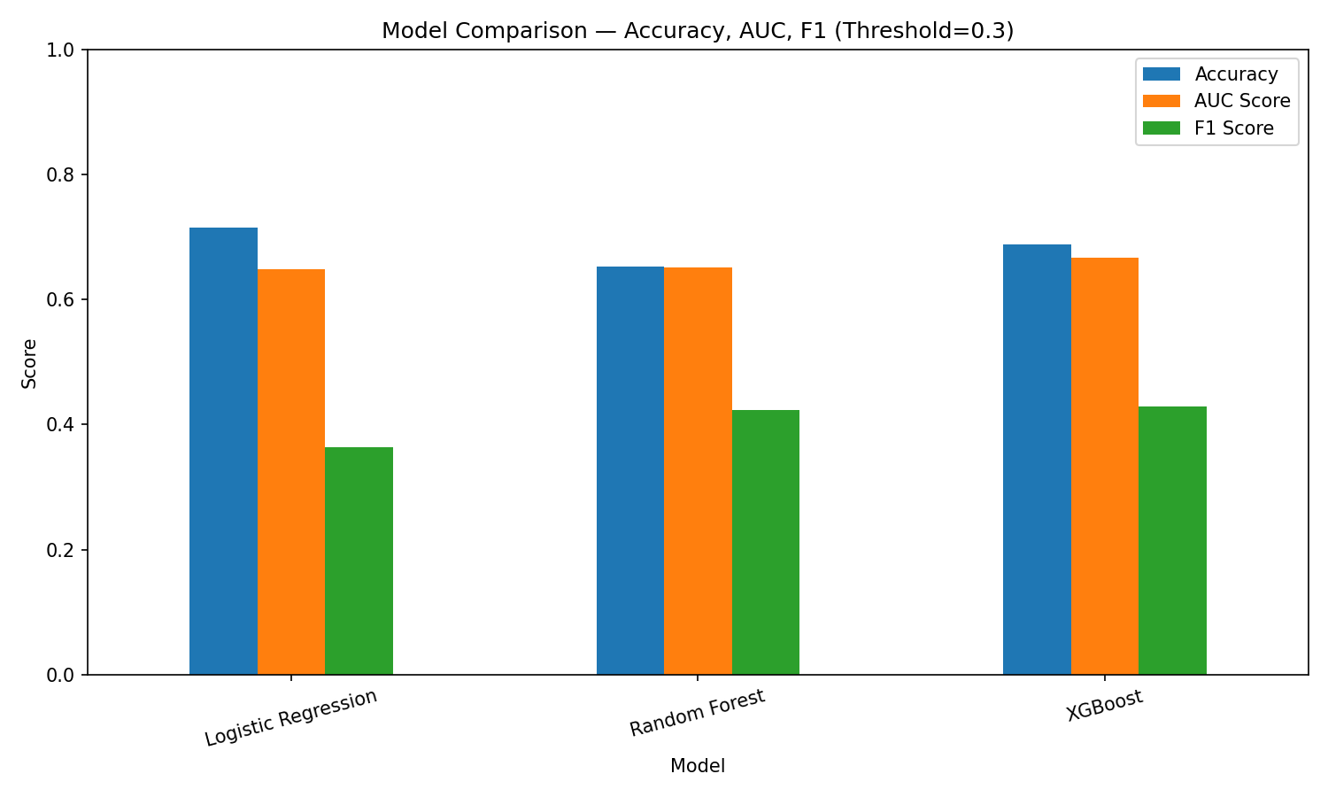
Figure 3 Class distribution of the target variable before and after balancing.

Model Selection and Justification
Three machine learning models were selected for this study. Each model was chosen for a specific reason. Together, they represent a progression from simple to complex, which allows for a meaningful comparison of performance.

Logistic Regression
The simplest model to be applied in the current study is the Logistic Regression. It is a statistical model that is used to predict the likelihood of a dichotomous event. It operates by determining a linear regression between the features of the input and the target variable. It has been selected as a reference model. A baseline is significant in that it provides a minimum level of performance standard. When more complex models are not able to achieve better results than the logistic regression, this indicates that the extra complexity is not justified. Logistic regression is also easy to interpret which is useful in the healthcare settings.

Random Forest
Random Forest is a model of ensemble. It creates numerous decision trees in the training process and integrates their predictions to form a final one. The trees in the forest are constructed with a random selection of the training data and a random selection of the features. This randomness prevents the model to overfit, i.e. when a model has been trained to work with the training data and fails to work with new data. Random Forest was selected, as it is able to deal with non-linear and complex relationships in the data and generally performs well when compared to logistic regression on clinical data.

XGBoost
XGBoost is an abbreviation, which means Extreme Gradient Boosting. It is a high-level ensemble technique, which constructs models sequentially. Every new model attempts to rectify the errors that the former made. It is known to do very well on tabular data which are structured and it is in wide usage in academic research and industry. XGBoost was also added since it outperforms other models, as it always performs best on similar healthcare prediction tasks and is likely to do so in this study.

Model | Type | Reason for Selection
Logistic Regression | Linear Classifier | Simple baseline, easy to interpret
Random Forest | Ensemble (Bagging) | Handles complex patterns, avoids overfitting
XGBoost | Ensemble (Boosting) | High performance on tabular data, sequential learning
Table 4 Machine learning models selected and their justification

Model Training
All the models were trained with the balanced training data set. The training process will be to feed the model with the input features (Xtrain) and the target labels (ytrain) in order to be able to learn the patterns that can be used to distinguish between high-risk and low-risk patients. In the case of Logistic Regression, the maximum number of iterations was set to 1,000 to make sure that the model had sufficient time to converge. In the case of Random Forest there were 100 decision trees. In the case of XGBoost, 100 boosting rounds were provided with log loss as the estimation. The rest of the settings were set to default values to prevent over-tuning and to ensure fairness in the comparison that was done between the models. All the models were randomly assigned the state of 42 so that the results can be reproducible. This implies that when the same code is executed a second time it will give the same output.

Model Evaluation Metrics
All models were tested on the held-out test set after training. Measures of performance were as follows. The reason behind the choice of these metrics is that this is a medical classification problem with a skewed dataset such that merely measuring the accuracy is insufficient.

Accuracy
Accuracy measures the percentage of total predictions that were correct. While useful as a general measure, it can be misleading when the dataset is imbalanced. For example, a model that always predicts the negative class would still achieve around 75% accuracy in this study, even though it would fail to identify any high-risk patient.

AUC-ROC Score
AUC-ROC score is the separation of the two classes of the model at all possible classification thresholds. AUC is the abbreviation of Area Under the Curve and ROC is the abbreviation of Receiver Operating Characteristic. The 0.5 indicates that the model is equivalent to random guessing. A 1.0 indicates a perfect separation. This measure is especially desired in medicine since it cannot be influenced by the imbalance of classes

F1 Score
Precision and recall are harmonic mean of F1 score. Precision is the percentage of the predicted high-risk patients who were, in fact, high risk. Recall is a measure of the number of the high-risk patients the model was able to detect. The F1 score is the most significant measure in this research balancing the two. The issue of missing a high-risk patient (low recall) is a severe healthcare error, hence F1 value adequately reflects this issue.

Decision Threshold Adjustment
The probability threshold of most classification models is 0.5 by default. It implies that a patient can only be considered as high risk when the model gives the probability of 50% or above. Nevertheless, in a medical setting it is generally more advisable to be more risk sensitive with a cost of false positives. In this analysis, the cut off point was reduced to 0.3. It implies that any patient with a risk probability of 30% or higher will be considered as high risk. This modification enhanced F1 scores of all three models.
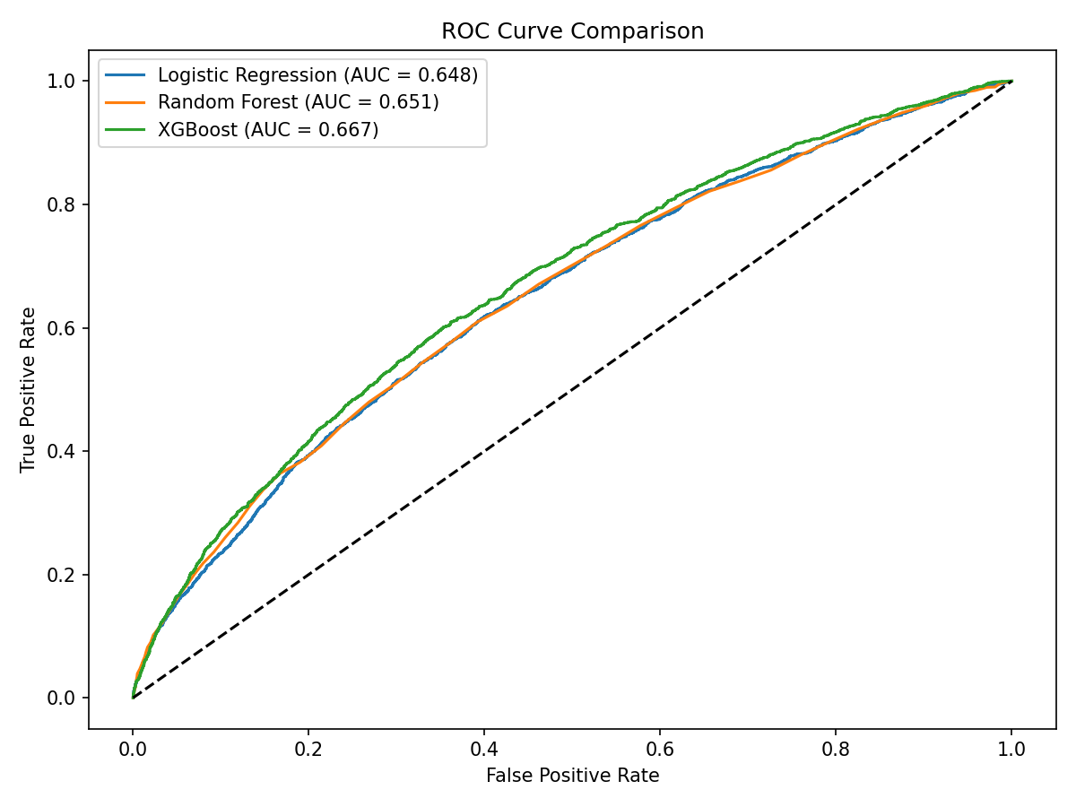
Figure 4 ROC curves comparing the three models. A higher curve indicates better performance.

SHAP Explainability
It is significant to create a model that makes accurate predictions. Yet in the medical field, it is also crucial to comprehend the rationale behind the prediction that is made by the model. Clinicians, and hospital administrators must be aware of which factors are driving the risk score of each patient. A model which cannot rationalize its decisions is hard to believe and is hardly likely to be put into practice.
Due to this reason, SHAP was applied in this research. SHAP is an abbreviation of SHapley Additive exPlainations. It is a game theory methodology that provides contributions scores towards each feature of a given prediction. It is a positive SHAP value indicating that the feature increased the prediction towards high risk. The negative value of SHAP indicates that it was pulled towards low risk. XGBoost model was used and SHAP was applied to this model which was the best performing model. The top 20 most important features and their influence on the predictions made on the test set were created into a summary plot.
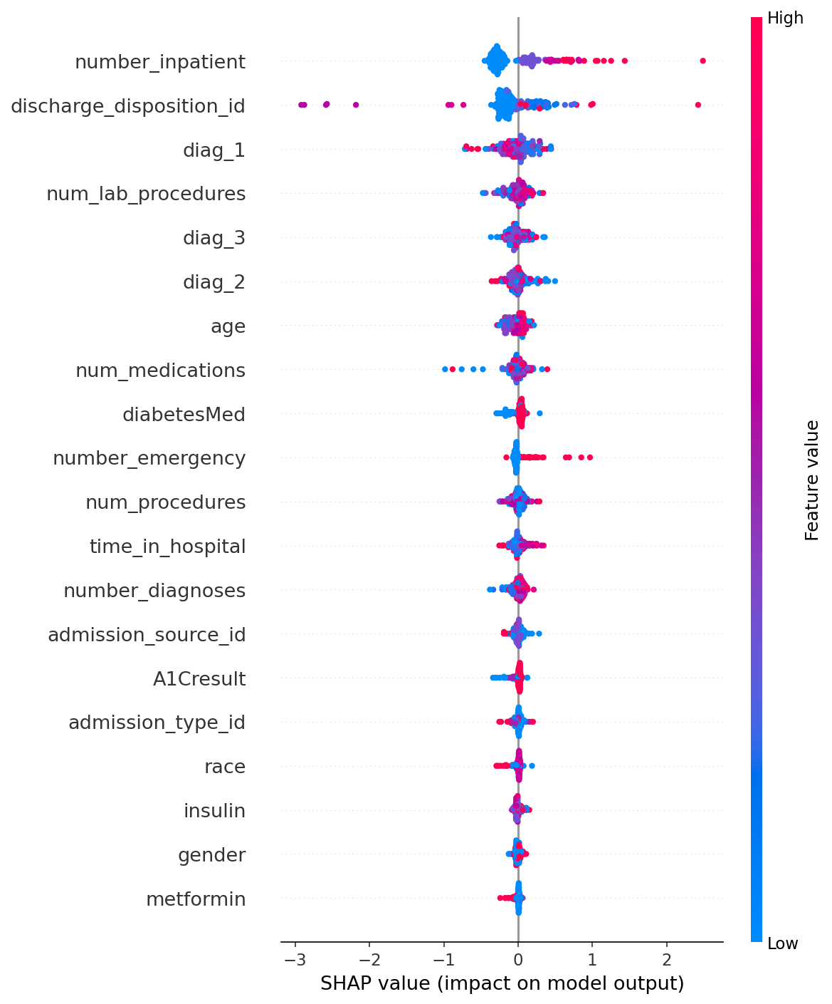
Figure 5 SHAP summary plot showing the impact of each feature on the XGBoost model predictions

Ethical Considerations and Dataset Limitations
Several important limitations of this dataset and study must be acknowledged.

Missing Social Determinants
The data set includes clinical and administrative data, but it does not cover social factors like the level of income, housing status, availability of transport, family support. These social determinants of health have been found to be a major cause of readmission in the hospitals. Any patient who is unable to afford medication or even has no one to take care of them in the home is in greater risk irrespective of his clinical profile. This study lacks these variables and could imply that the models could be underestimating risk in socially vulnerable patients. The dataset has insurance type which gives a partial proxy of the socioeconomic status. This weakness is recognized in the chapter of discussion.

Data Age
The data was gathered in 1999-2008. Medications, patient care plans and methods of healthcare have significantly evolved since that time. The patterns observed in the contemporary hospitals might not be perfectly reflected in the models which are trained on this data. Nevertheless, the dataset is the most common benchmark to predict diabetic readmissions and its utilization enables its comparison with a significant amount of already existing studies.

Bias in Historical Data
Machine learning models are learnt based on historical data. In case some biases were used to make historical clinical decisions, such as when some groups of patients were not provided with comprehensive care, the biases might be reinforced in the model predictions. The dataset has the variable of race. Its inclusion was not aimed at making discriminating predictions but to reflect any disparities of health in the data. This should be taken into consideration in the interpretation of results.

Ethical Use
The data in this study is de-identified patient data, obtained in a public repository. The data do not allow identifying any individual patients. These models are created to help with the clinical decision making process and enhance patient outcomes, not to substitute clinical judgment. Such a model would need ethical, clinical validation and regulatory supervision to be applied in any real-world setting.

Tools and Technologies
The entire analysis was conducted in Python using Jupyter Notebook. The following libraries and tools were used throughout the study.
Tool / Library | Purpose
Python 3 | Primary programming language
Jupyter Notebook | Interactive coding environment
Pandas | Data loading, cleaning, and manipulation
NumPy | Numerical operations
Scikit-learn | Logistic Regression, Random Forest, evaluation metrics
XGBoost | XGBoost classifier
SHAP | Model explainability and feature importance
Matplotlib | Data visualization and chart generation
Seaborn | Statistical visualizations
UCI ML Repository | Source of the Diabetes 130-US Hospitals dataset
Table 5 Tools and libraries used in the study.

Summary
The entire methodology in this study has been outlined in this chapter. The UCI repository was used to obtain diabetes 130-US Hospitals dataset. It has 101,766 actual patient data of 130 hospitals in US. To manage the class imbalance problem, the data was cleaned, preprocessed and balanced. Three machine learning models were created as a baseline, intermediate model, and advanced model as the XGBoost.
The Accuracy, AUC-ROC, and F1 Score were used to evaluate each of the models. A threshold of 0.3 was used to enhance sensitivity when it comes to identifying high-risk patients. The explanations of the features that were used to drive the model predictions were done through SHAP. Major constraints of the dataset such as the lack of social factors, the age of data or the possible bias were addressed as well. The outcomes of the model assessment are provided. The results of the model evaluation are presented and discussed in detail in Chapter 4.

References
Abdul Basith Khan, M., Hashim, M. J., King, J. K., Govender, R. D., Mustafa, H., & Al Kaabi, J. (2020). Epidemiology of type 2 diabetes—global burden of disease and forecasted trends. Journal of epidemiology and global health, 10(1), 107-111. https://link.springer.com/content/pdf/10.2991/jegh.k.191028.001
Ben-Assuli, O., Kumar, N., Arazy, O., & Shabtai, I. (2020). The use of analytic hierarchy process for measuring the complexity of medical diagnosis. Health Informatics Journal, 26(1), 218-232., https://doi.org/10.1177/1460458218824708.
Blick, C. A., Williams, B. P., Myers, D. T., Pomranke, J., Clemente, S. M., & Coustasse, A. (2023). Relationship between the Hospital Readmission Reduction Program and Readmissions, Postoperative Complications, and Cost. https://mds.marshall.edu/cgi/viewcontent.cgi?article=1252&context=mgmt_faculty
Chand, S. P. (2025). Methods of data collection in qualitative research: Interviews, focus groups, observations, and document analysis. Advances in Educational Research and Evaluation, 6(1), 303-317. https://doi.org/10.25082/AERE.2025.01.001
Chandrasekaran, P., & Weiskirchen, R. (2024). The role of obesity in type 2 diabetes mellitus—An overview. International journal of molecular sciences, 25(3), 1882. https://doi.org/10.3390/ijms25031882
Chronic Care Management Services FAQs | CareVitality. (2020). Retrieved December 8, 2025, from CareVitality website: https://carevitality.com/care-management-services/chronic-care-management-faqs/
Cilloniz, C., Ward, L., Mogensen, M. L., Pericàs, J. M., Méndez, R., Gabarrús, A., ... & Torres, A. (2023). Machine-learning model for mortality prediction in patients with community-acquired pneumonia: development and validation study. Chest, 163(1), 77-88., https://papers.ssrn.com/sol3/Delivery.cfm?abstractid=3880457.
Dar, Y., Muthukumar, V., & Baraniuk, R. G. (2021). A farewell to the bias-variance tradeoff? an overview of the theory of overparameterized machine learning. arXiv preprint arXiv:2109.02355. https://arxiv.org/pdf/2109.02355
Data, M. C. (2016). Secondary analysis of electronic health records (Vol. 183). Cham: Springer International Publishing.
De Graaf, N. P., Roffel, S., Gibbs, S., Kleverlaan, C. J., Lopez Gonzalez, M., Rustemeyer, T., ... & Bontkes, H. J. (2023). Nickel allergy is associated with a broad-spectrum cytokine response. Contact Dermatitis, 88(1), 10-17. DOI: 10.1111/cod.14199
diabetes mellitus and its complications. Nature Reviews Endocrinology, 14(2), 88–98. https://www.nature.com/articles/nrendo.2017.151
Fortin, M., & Stewart, M. (2021). Implementing patient-centred integrated care for multiple chronic conditions: evidence-informed framework. Canadian Family Physician, 67(4), 235-238. DOI: http://10.46747/cfp.6704235
Goh, L. H., Siah, C. J. R., Tam, W. W. S., Tai, E. S., & Young, D. Y. L. (2022). Effectiveness of the chronic care model for adults with type 2 diabetes in primary care: a systematic review and meta-analysis. Systematic Reviews, 11(1), 273. https://doi.org/10.1186/s13643-022-02117-w
Gosmanov, A. R., Gosmanova, E. O., & Kitabchi, A. E. (2021). Hyperglycemic crises: diabetic ketoacidosis and hyperglycemic hyperosmolar state. Endotext [Internet]. https://www.ncbi.nlm.nih.gov/sites/books/NBK279052/
Han, F., Shi, X. L., Pan, J. J., Wu, K. Y., Zhu, Q. T., Yuan, C. C., ... & Li, W. Q. (2023). Elevated serum HbA1c level, rather than earlier history of diabetes, predicts the disease severity and clinical outcomes of acute pancreatitis. BMJ Open Diabetes Research & Care, 11(1), doi: https://10.1136/bmjdrc-2022-003070
Health IT Analytics. (2026). TechTarget Enterprise Technology News | Health IT. Retrieved February 12, 2026, from Healthitanalytics.com website: https://healthitanalytics.com/news/over-80-of-health-execs-have-artificial-i
Helm, J. M., Swiergosz, A. M., Haeberle, H. S., Karnuta, J. M., Schaffer, J. L., Krebs, V. E., ... & Ramkumar, P. N. (2020). Machine learning and artificial intelligence: definitions, applications, and future directions. Current reviews in musculoskeletal medicine, 13(1), 69-76, https://doi.org/10.1007/s12178-020-09600-8.
Hemmingsen, S. L., Bøhm, P. W., Jensen, J. F., Kirk, J. W., & Møller, T. (2025). Elderly Medical Patients' Experience of an Acute Readmission to the Emergency Department—An Interpretative Phenomenological Analysis. Scandinavian Journal of Caring Sciences, 39(4), e70155. https://doi.org/10.1111/scs.70155
https://diabetesatlas.org/resources/factsheets/
Hu, T. L., Chao, C. M., Wu, C. C., Chien, T. N., & Li, C. (2024). Machine learning-based predictions of mortality and readmission in type 2 diabetes patients in the ICU. Applied Sciences, 14(18), 8443. https://doi.org/10.3390/app14188443
International Diabetes Federation. (2025). from Diabetes Atlas website:
Jayatilake, S. M. D. A. C., & Ganegoda, G. U. (2021). Involvement of machine learning tools in healthcare decision making. Journal of healthcare engineering, 2021(1), 6679512. https://doi.org/10.1155/2021/6679512
Jha, V., Al-Ghamdi, S. M., Li, G., Wu, M. S., Stafylas, P., Retat, L., ... & Garcia Sanchez, J. J. (2023). Global economic burden associated with chronic kidney disease: a pragmatic review of medical costs for the inside CKD research programme. Advances in Therapy, 40(10), 4405-4420, https://doi.org/10.1007/s12325-023-02608-9.
Jiang, J. (2020). Interpretable Learning for Hospital Readmission Prediction from Healthcare Data (Doctoral dissertation, State University of New York at Buffalo), https://www.proquest.com/openview/29350f9131c77e941f08cca554f79160/1?pq-origsite=gscholar&cbl=18750&diss=y.
Johnson, M. (2025). Reducing 30-day Diabetic Ketoacidosis Readmissions Among Individuals with Type 1 Diabetes Through a Transition of Care Program (Doctoral dissertation, CALIFORNIA STATE UNIVERSITY SAN MARCOS). https://scholarworks.calstate.edu/downloads/76537b014
Khin, P. P., Lee, J. H., & Jun, H. S. (2023). Pancreatic beta-cell dysfunction in type 2 diabetes. European Journal of Inflammation, 21, 1721727X231154152. https://doi.org/10.1177/1721727X231154152
Kum Ghabowen, I., Epane, J. P., Shen, J. J., Goodman, X., Ramamonjiarivelo, Z., & Zengul, F. D. (2024, March). Systematic review and meta-analysis of the fiscal impact of 30-Day readmissions for selected medical conditions: a focus on Hospital quality performance. In Healthcare (Vol. 12, No. 7, p. 750). MDPI. https://doi.org/10.3390/healthcare12070750
Kumar, S., & Ujire, D. K. (2024). Inductive and deductive approaches to qualitative research. International Journal of Multidisciplinary Educational Research, 13(1), 58-63. http://ijmer.in.doi./2024/13.1.69
Li, C., Liao, C., Meng, X., Chen, H., Chen, W., Wei, B., & Zhu, P. (2021). Effective analysis of inpatient satisfaction: the random forest algorithm. Patient preference and adherence, 691-703. https://doi.org/10.2147/PPA.S294402
Mahmoudi, E., Kamdar, N., Kim, N., Gonzales, G., Singh, K., & Waljee, A. K. (2020). Use of electronic medical records in development and validation of risk prediction models of hospital readmission: systematic review. bmj, 369. http://dx.doi.org/10.1136 bmj.m958
Martínez-García, M., & Hernández-Lemus, E. (2022). Data integration challenges for machine learning in precision medicine. Frontiers in medicine, 8, 784455, https://doi.org/10.3389/fmed.2021.784455.
Mayo Clinic. (2025). Type 2 diabetes. Retrieved from Mayo Clinic website: https://www.mayoclinic.org/diseases-conditions/type-2-diabetes/symptoms-causes/syc-20351193.
Mohebbi, A. (2020). Factors Related to 30-Day Readmission Among Hispanic Adults with Type 2 Diabetes (Doctoral dissertation, University of San Diego). https://search.proquest.com/openview/a0761e09bc4567fface6f340003fd838/1?pq-origsite=gscholar&cbl=18750&diss=y
NCBI Bookshelf. https://www.ncbi.nlm.nih.gov/books/NBK606114/
Olalekan Kehinde, A. (2025). Leveraging machine learning for predictive models in healthcare to enhance patient outcome management. Int Res J Mod Eng Technol Sci, 7(1), 1465. DOI: https://www.doi.org/10.56726/IRJMETS66198
Owusu, E., Oluwasina, F., Nkire, N., Lawal, M. A., & Agyapong, V. I. (2022). Readmission of patients to acute psychiatric hospitals: influential factors and interventions to reduce psychiatric readmission rates. In Healthcare (Vol. 10, No. 9, p. 1808). MDPI. https://doi.org/10.3390/healthcare10091808
Qiu, L., Kumar, S., Sen, A., & Sinha, A. P. (2022). Impact of the Hospital Readmission Reduction Program on hospital readmission and mortality: An economic analysis. Production and Operations Management, 31(5), 2341-2360. https://doi.org/10.1111/poms.13724
Rajaguru, V., Han, W., Kim, T. H., Shin, J., & Lee, S. G. (2022). LACE index to predict the elevated risk of 30-day readmission: a systematic review and meta-analysis. Journal of personalized medicine, 12(4), 545. https://doi.org/10.3390/jpm12040545
Rane, N., Choudhary, S. P., & Rane, J. (2024). Ensemble deep learning and machine learning: applications, opportunities, challenges, and future directions. Studies in Medical and Health Sciences, 1(2), 18-41. DOI: https://doi.org/10.48185/smhs.v1i2.1225
Readmission of Patients to Acute Psychiatric Hospitals: Influential Factors and Interventions to Reduce Psychiatric Readmission Rates. Healthcare, 10(9), 1808. https://doi.org/10.3390/healthcare10091808
Redondo, M. J., Hagopian, W. A., Oram, R., Steck, A. K., Vehik, K., Weedon, M., ... & Dabelea, D. (2020). The clinical consequences of heterogeneity within and between different diabetes types. Diabetologia, 63(10), 2040-2048. https://doi.org/10.1007/s00125-020-05211-7
Regan, E. A. (2022). Changing the research paradigm for digital transformation in healthcare delivery. Frontiers in Digital Health, 4, 911634. https://doi.org/10.3389/fdgth.2022.911634
Regassa, L. D., & Tola, A. (2021). Size and predictors of hospital admission, readmission, and length of stay among patients with type 2 diabetes at public hospitals of Eastern Ethiopia: a retrospective cohort study. BMC Endocrine Disorders, 21(1), 74, https://doi.org/10.1186/s12902-021-00744-3.
Renzulli, J. S. (2021). The three-ring conception of giftedness: A developmental model for promoting creative productivity 4. In Reflections on gifted education (pp. 55-90). Routledge https://gifted.media.uconn.edu/wp-content/uploads/sites/961/2025/01/The-Three-Ring-Conception-of-Giftedness.pdf
Rolek, B., Haber, M., Gajewska, M., Rogula, S., Pietrasik, A., & Gąsecka, A. (2023). SGLT2 Inhibitors vs. GLP-1 Agonists to Treat the Heart, the Kidneys and the Brain. Journal of cardiovascular development and disease, 10(8), 322. https://doi.org/10.3390/jcdd10080322
Sahin, E. K. (2020). Assessing the predictive capability of ensemble tree methods for landslide susceptibility mapping using XGBoost, gradient boosting machine, and random forest. SN Applied Sciences, 2(7), 1308. https://doi.org/10.1007/s42452-020-3060-1
Santos, H. D. P. D. (2021). Applying machine learning to electronic health records: a study on two adverse events, https://repositorio.pucrs.br/dspace/bitstream/10923/17324/1/000499885-Texto%2Bcompleto-0.pdf.
Sbitan, L., Alzraikat, N., Tanous, H., Saad, A.M. & Odeh, M., (2025). From one size fits all to a tailored approach: integrating precision medicine into medical education. BMC Medical Education, 25(1), p.90. https://doi.org/10.1186/s12909-024-06138-y
Sharma, A., Mittal, S., Aggarwal, R., & Chauhan, M. K. (2020). Diabetes and cardiovascular disease: inter-relation of risk factors and treatment. Future Journal of Pharmaceutical Sciences, 6(1), 130. https://doi.org/10.1186/s43094-020-00151-w
Shen, Y., Zhou, J., & Hu, G. (2020). Practical use of electronic health records among patients with diabetes in scientific research. Chinese medical journal, 133(10), 1224–1230. https://doi.org/10.1097/CM9.0000000000000784
Sivarajkumar, S. (2025). Natural Language Processing for Information Extraction and Predictive Modeling in Healthcare (Doctoral dissertation, University of Pittsburgh). https://search.proquest.com/openview/e03dd890000f46d0005d1205e25464e1/1?pq-origsite=gscholar&cbl=18750&diss=y
Soh, J. G. S., Wong, W. P., Mukhopadhyay, A., Quek, S. C., & Tai, B. C. (2020). Predictors of 30-day unplanned hospital readmission among adult patients with diabetes mellitus: a systematic review with meta-analysis. BMJ open diabetes research & care, 8(1). https://drc.bmj.com/content/bmjdrc/8/1/e001227.full.pdf
Tan, A. L., Getzen, E. J., Hutch, M. R., Strasser, Z. H., Gutiérrez-Sacristán, A., Le, T. T., ... & Holmes, J. H. (2023). Informative messingness: What can we learn from patterns in missing laboratory data in the electronic health record? Journal of biomedical informatics, 139, 104306.
Timpel, P., Lang, C., Wens, J., Contel, J. C., Schwarz, P. E., & Manage Care Study Group. (2020). The Manage Care model–developing an evidence-based and Expert-Driven Chronic Care Management Model for patients with diabetes. International journal of integrated care, 20(2), 2. https://pmc.ncbi.nlm.nih.gov/articles/PMC7181948/pdf/ijic-20-2-4646.pdf
Tun, S. Y. Y., & Madanian, S. (2023). Clinical information system (CIS) implementation in developing countries: requirements, success factors, and recommendations. Journal of the American Medical Informatics Association, 30(4), 761-774. https://doi.org/10.1093/jamia/ocad011
Wakim, N. I., Braun, T. M., Kaye, J. A., Dodge, H. H., & ORCATECH. (2020). Choosing the right time granularity for analysis of digital biomarker trajectories. Alzheimer's & Dementia: Translational Research & Clinical Interventions, 6(1), e12094. DOI: 10.1002/trc2.12094
Wang, R.C. & Wang, Z., (2023). Precision medicine: disease subtyping and tailored treatment. Cancers, 15(15), p.3837, https://doi.org/10.3390/cancers15153837.
Wang, S., & Zhu, X. (2021). Predictive modeling of hospital readmission: challenges and solutions. IEEE/ACM transactions on computational biology and bioinformatics, 19(5), 2975-2995. https://doi.org/10.1109/TCBB.2021.3089682
Zakir, M., Ahuja, N., Surksha, M. A., Sachdev, R., Kalariya, Y., Nasir, M., ... & Ali, M. (2023). Cardiovascular complications of diabetes: from microvascular to macrovascular pathways. Cureus, 15(9). DOI: 10.7759/cureus.45835, https://pubmed.ncbi.nlm.nih.gov/37881393/
Zheng, Y., Ley, S. H., & Hu, F. B. (2018). Global aetiology and epidemiology of type 2 diabetes mellitus and its complications. Nature reviews endocrinology, 14(2), 88-98. http://dx.doi.org/10.1038/nrendo.2017.151

